The Ultimate Guide to Screwdrivers: Types, Sizes, and Uses

The Ultimate Guide to Screwdrivers, a screwdriver is a handheld tool that is commonly used to tighten or loosen screws. It is a simple and versatile tool that is found in almost every household and workplace. The basic design of a screwdriver consists of a handle and a shaft with a flat, wedge-shaped tip called a blade. The blade is inserted into the slot or recess in the screw head and then turned to either tighten or loosen the screw.

[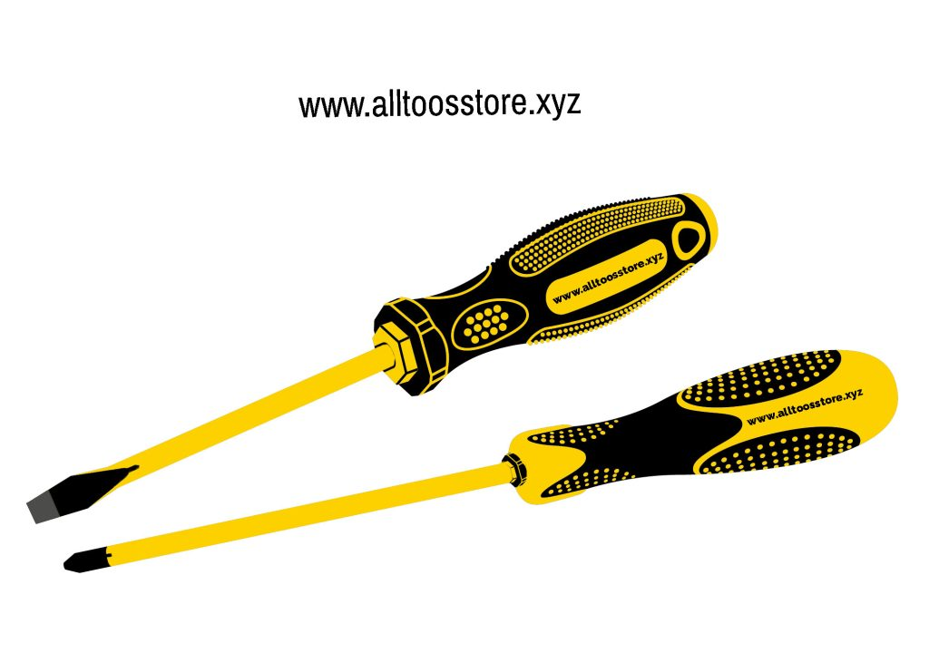](https://www.daraz.com.bd/products/tolsen-2-in-1-interchangeable-screwdriver-set-philip-flat-tpr-handle-model-20042-i104798925-s1019612989.html?spm=a2a0e.searchlistcategory.list.13.1316218aMFObj3&search=1)The Ultimate Guide to Screwdrivers: Types, Sizes, and Uses

**Most common uses of screwdrivers include**

* Electronics equipment
* Mobile Servicing
* Computers
* Mechanical
* Industrial production
* Woodworking and carpentry workshop

There are several types of screwdrivers available, each designed to work with a specific type of screw head. The most common types of screwdriver blades are the slotted or flat blade, Phillips, and Torx. Interchangeable Screwdriver Set (Philip & Flat) TPR Handle, Slotted or flat blade screwdrivers have a single flat blade that fits into the slot or recess of the screw head. Phillips screwdrivers have a cross-shaped tip that fits into a corresponding recess in the screw head. Torx screwdrivers have a six-pointed star-shaped tip that fits into a recess in the screw head.

**Types of Screwdrivers**

* Phillips Screwdriver
* Star Screwdriver
* Insulated Screwdrivers
* Torque Screwdrivers
* Flathead Screwdriver
* Tri-Wing Screwdrive**r**
* Square Screwdriver

**Screwdriver Sizes**

[The Ultimate Guide to Screwdrivers](http://www.alltoolsstore.xyz/): Screwdrivers come in a variety of sizes, with the most common being small, medium, and large. Small screwdrivers are used for delicate work, such as repairing electronic devices, while larger screwdrivers are used for heavier-duty work, such as assembling furniture or tightening bolts, there are also stubby screwdrivers that are ideal for use in tight or confined spaces. The tip width and the length of both the blade and the overall tool are usually measured in millimeters (mm).

In addition to the standard screwdriver, there are also electric and cordless screwdrivers that can make the job of tightening and loosening screws faster and easier. These tools are particularly useful when working with a large number of screws or screws that are difficult to reach.

When using a screwdriver, it’s important to choose the right size and type of screwdriver blade for the job. The screw head may become damaged if the incorrect size or kind of screwdriver is used, making removal challenging or impossible. It’s also important to use the correct amount of force when turning the screwdriver to avoid stripping the screw or damaging the blade.

**Parts of a Screwdriver**

* Handle
* Shank
* Blade
* Tip

Overall, screwdrivers are a simple yet essential tool that is used in a wide range of applications. Whether you’re a DIY enthusiast or a professional tradesperson, having a good set of screwdrivers on hand can make many jobs easier and more efficient.

|  |  |
| --- | --- |
| Pros: | Cons: |
| 1. Informative: The content provides a comprehensive overview of screwdrivers, including their types, uses, and maintenance tips, which can be helpful for beginners and DIY enthusiasts. 2. Educational: The content offers educational value by explaining the different types of screwdrivers and how to choose the right one for the job. 3. Engaging: The content is written in a clear and concise manner, making it easy to read and understand. 4. Relevant: The content is relevant to your website’s topic, which is tools and equipment information. | 1. Limited scope: The content covers only the basics of screwdrivers and their uses. It may not be suitable for those looking for in-depth knowledge or technical details. 2. Lack of visuals: The content does not include any images or diagrams, which can make it harder for readers to understand some of the concepts. 3. No unique selling point: The content does not offer any unique perspective or original research, which may not set it apart from other similar content on the internet. |

**FAQs**

1. What are the different types of screwdrivers?
2. How do I choose the right screwdriver for the job?
3. Can electric screwdrivers be used for all types of screws?
4. What are the most common mistakes people make when using screwdrivers?